|  |  |
| --- | --- |
| Assessment Title | Software Requirements |

## Competency Details

|  |  |
| --- | --- |
| Unit code/s and title/s | ICTPRG546 - Validate application designs against specifications |
| Qualification code/s and title/s | ICT50220 Diploma in Information Technology |
| Business unit/Work group | Business and Arts/IT Studies |

## Instructions

|  |  |
| --- | --- |
| Method/s of assessment | Questioning (Written)  Product (Written assignment)  Oral communication (Client Meeting) |
| Overview of assessment | This assessment will require you to:   * Complete written questions within this document. * Provide screen captures for written questions within this document. * Find and review a software specifications document * Discuss software requirements with your client |
| Task/s to be assessed | This assessment will require you to complete the following tasks   * Identify existing software specifications * Evaluate existing software against requirements * Validate software requirement specifications |
| Time allowed | Refer to your schedule for submission dates |
| Location of assessment | Assessment can be completed anywhere with access to the resources required. (See Resources Required section below) |
| Decision making rules | To receive a satisfactory outcome for this assessment you must complete all parts correctly.  Word counts are provided as guidance only. |
| Assessment conditions | This assessment must be undertaken where conditions are typical of a work environment requiring cyber secure practices, processes, and procedures.  This is an unsupervised assessment, and you may access any required resources. |
| Resources required | To complete this assessment, you will require the following:  Software needed on class computers includes:   * Microsoft Windows 10 * Microsoft Office 2016   The following documents will be required:   * ICTPRG546 - ASDS – SPS software requirements.   You can complete on your own computers or laptops if you are able to source the above requirements. |
| Result notification and reassessment information | You will be provided feedback and the result for your assignment on TAFESA Learn. You will be and given the chance to resubmit with required corrections only once.  Refer to the TAFE SA assessment policy for more information <https://www.tafesa.edu.au/apply-enrol/before-starting/student-policies/assessment> |

**SCENARIO**

You have been asked by ITWorks to complete a software project on a study plan system (SPS) for a client. The client currently has a system which does not meet all its needs. A software requirements specification document has been completed for the project and you will need to access this for more information about what is required moving forward.

You must organise a time with the client to look at their existing software to better understand the remaining steps in the project.

**Existing software specifications document**

List the existing documentation that exists for the SPS Project:

## ICTPRG546 - ASDS - ITWorks Schema.png

## ICTPRG546 - ASDS - ITWorks_SPS_Test_Plan.docx

## ICTPRG546 – ASDS – SPS software design document.docx

## ICTPRG546 - ASDS - SPS Software Requirements Specification.docx

Write the SharePoint path and provide a screenshot of where you found this documentation:

TG-ITStudies-ITWORKS -> ITWorks -> SPS Project

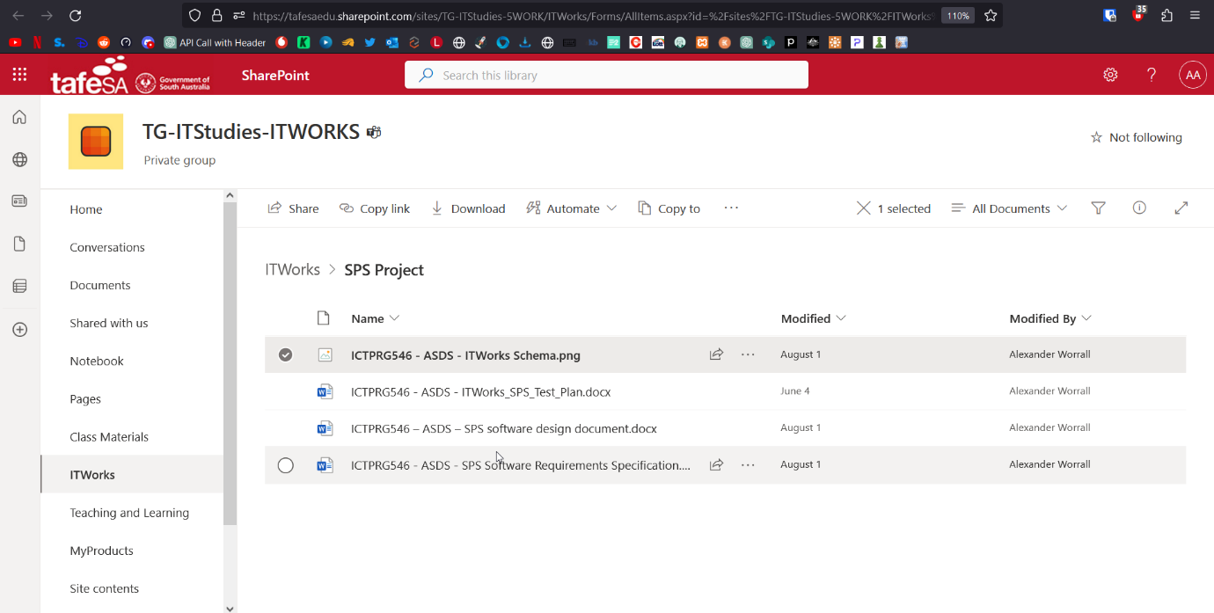

**Alignment to requirements**

Using the software specifications requirement document and the existing SPS software application, list:

* Minimum three features that still need to be implemented
* Must be a web application
* Modern user interface with drag and drop capabilities
* User must be able to log in using their existing lecturer or student details
* What changes need to be made to the hosting of the application

 Move database from local to on a server.

**Meeting with the client about requirements**

You are to organise an meeting with the client from the training provider that will be utilising the SPS application (Your Lecturer).  You can do this in the classroom, or in a Virtual Classroom. External students are to email their Lecturer to arrange a time to speak either over a Teams meeting, or phone.

In the meeting you will be discussing and confirming the information that is contained in the software requirements specification document. The meeting should take no longer than 10 minutes.

You must discuss with the client the requirements they have for the software application and any features that might be missing from the document.

Login screen, current tafe details

Rego screen, student search, see completed units, semester, list of units (current, completed and need to do).